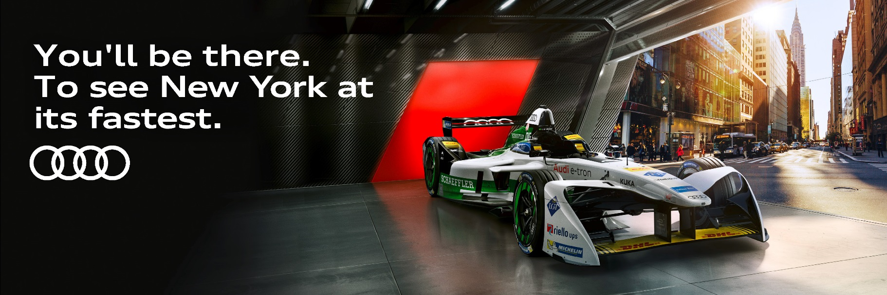
Join Audi NZ in New York City for an electrifying experience!

FRIDAY 13th JULY 2018

Depart New Zealand to New York today on either of the below Economy Class options:

- Flying Air New Zealand and United Airlines to New York
- Flying Hawaiian Airlines via Honolulu to New York

On arrival in New York City you will transferred to your hotel, which has been reserved for the next three nights.

The rest of the evening is yours to enjoy at your leisure.

SATURDAY 14th JULY 2018

This morning a Welcome Breakfast will be hosted by Audi NZ.

Meet in the hotel lobby for your transfer to the Brooklyn Street Circuit to enjoy a day of Formula E racing.

This afternoon you will meet back at the drop off point for your transfer back to your hotel.

The rest of the evening is yours to enjoy at your leisure.

SUNDAY 15th JULY 2018

This morning breakfast will be served in the hotel restaurant.

Meet in the hotel lobby for your transfer to the Brooklyn Street Circuit to enjoy a day of Formula E racing, or join us on our See New York with Juliette Hogan Tour (more information below).

This afternoon you will meet back at the drop off point for your transfer back to your hotel.

Tonight, Audi NZ will host you for a Farewell Dinner & Drinks.

Formalities will end and the rest of the evening is at your leisure.

MONDAY 16th JULY 2018

This morning breakfast will be served in the hotel restaurant.

You will be required to check out of your room and settle your bill for any incidentals including mini-bar, bar tabs etc.

If you have chosen to extend your stay in New York, we bid you farewell.

If you are travelling to another US city or home to New Zealand today, your hotel will offer luggage storage so you can leave your bags at the hotel and enjoy some free time prior to your transfer to the airport.

Transfer from your hotel to the Airport for your onward flight.

Depart New York today on either of the below Economy Class options:

- Flying United Airlines and Air New Zealand
- Flying Hawaiian Airlines via Honolulu

OPTIONAL DAY TOUR: See New York with Juliette Hogan

We invite you to join us on Sunday 15th July for a closed door shopping experience with Juliette Hogan and a New York-based fashion designer, followed by lunch at one of Juliette’s favorite NYC restaurants. We will then transfer you to Brooklyn for the final afternoon of Formula E racing, or back to the hotel for some free time.

IMPORTANT INFORMATION

VISA REQUIREMENT:
You will be required to have an ESTA (electronic) visa to enter the United States of America which you can apply for online at: https://esta.cbp.dhs.gov/esta/. To apply for this visa, you must have a valid passport, a credit card, and an email address, as well as a few minutes, to complete the online form.

TRAVEL INSURANCE:
Travel Insurance is essential. Please contact us if you have not yet got a policy in place. As a client of Holland Clarke & Beatson you will be able to take advantage of Allianz Travel Insurance. We have selected this Insurance product as we believe it to be New Zealand’s leading Travel Insurance provider. For full details of the level of cover required and all terms and conditions, please request a brochure from us and read the terms and conditions carefully and do not hesitate to contact us if you need further clarification.

EXTENDING YOUR STAY:
If you would like to extend your stay in the United States of America, any additional arrangements will be at your own cost. Prices are available upon application. Please indicate your wish to extend your stay on the Registration Form on this website, and one of our consultants will be in touch to discuss your plans.

AIRPORT TRANSFERS:
Return Airport Transfers have been included for all passengers arriving and departing on our Group Flights (arriving on 13 July & departing on 16 July). If you are not travelling on one of our Group Itineraries, you will need to make your own way to the hotel. Alternatively, we can arrange a transfer on your behalf. Prices are available upon request.

HAWAIIAN AIRLINES FLIGHT OPTION:
The flight itinerary with Hawaiian Airlines requires a stopover in Honolulu for a minimum 2 nights. Accommodation in Honolulu is not included, and hotel pricing will be available upon application. Please indicate on your Registration Form that you would like to travel with Hawaiian Airlines, and one of our consultants will be in touch to discuss your travel plans.

TIPPING:
In the USA it is customary to tip for xxxxx
All gratuities, taxes & service charges have been included in our package for you. However, if you are extending your stay xxxxxx

The flight itinerary with Hawaiian Airlines requires a minimum 2 night stopover in Honolulu on the return journey. Accommodation in Honolulu is not included. Any costs associated with this stopover will be at your own expense. Prices are available on application.
The flight itinerary with Hawaiian Airlines requires a minimum 2 night stopover in Honolulu on the return journey. Accommodation in Honolulu is not included. Any costs associated with this stopover will be at your own expense. Prices are available on application.

